**Compiler Based Languages(C, C++, Java)**

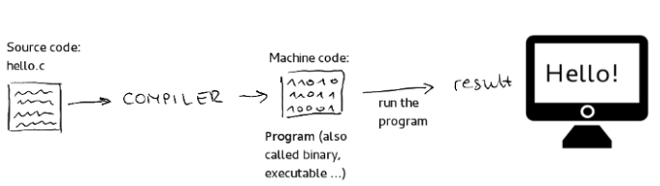

**Interpreter Based Languages(Python, Perl, JavaScript, Ruby)**

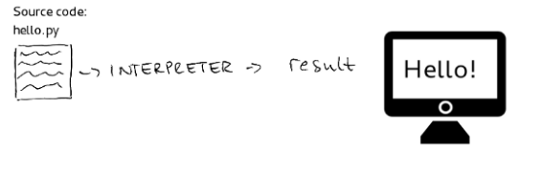

**Transpiled Languages(TypeScript,CoffeeScript)**

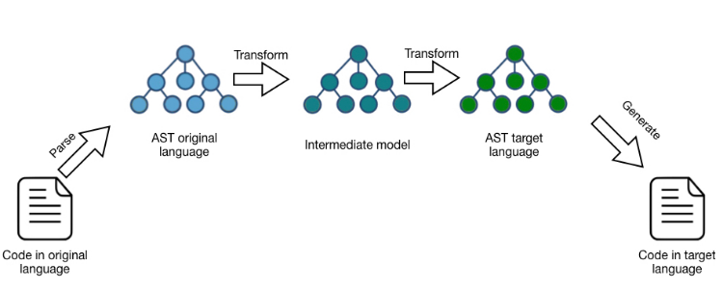

The purpose of this project is to create an entry-level programming language for those who are getting their first step in Computer Science. Currently, all the entry-level languages available are hard to understand for those who are newbies. Our aim is to create easy to understand language.